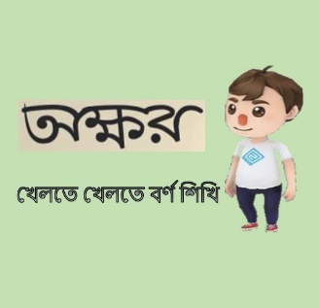

**অক্ষর**

(খেলতে খেলতে বর্ণ শিখি)

**Developed by**



**App Type:**

Game

**Category:**

Educational Game (শিক্ষামূলক অ্যাপ)

**Description:**

This is a well designed Educational 3D Game for the kids who are still not going to school or attending playgroup class level and learning to recognize the Alphabets and numbers. This game will help them to get the proper pronunciation with fun. In this game kids will be able to learn English alphabets, Numeric alphabets and Bengali alphabets. This will also help illiterate people to learn alphabets and number.

There are 4 stages. Each stage is considered as a chapter. Stage 1 has English alphabets, stage 2 has English numeric letters, stage 3 has Bangla vowels and stage 4, the final stage of the game has Bangla consonant letters. There are correct pronunciations of every letter given in the game. This game can be very helpful to all of you and to your kids.

খেলতে খেলতে বর্ণ শিখি। এই গেমটির মাধ্যমে আপনার ছোট্ট সোনামনিরা বাংলা বর্ণ, ইংরেজী বর্ণ এবং সংখ্যা গুলো চিনতে ও উচ্চারণ শিখতে পারবে।

**How to play:**

1. First download the game.
2. Open the অক্ষর app.
3. Press the Play button.

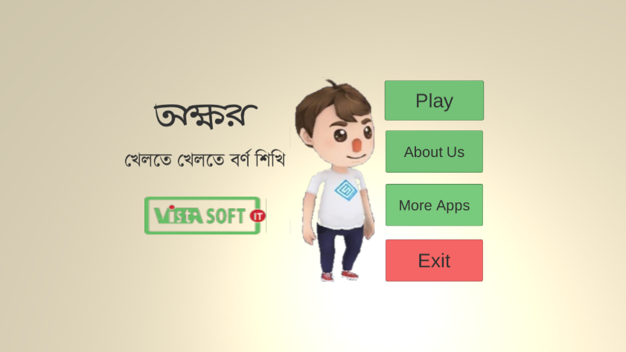

1. Select or press “Stage 1” button

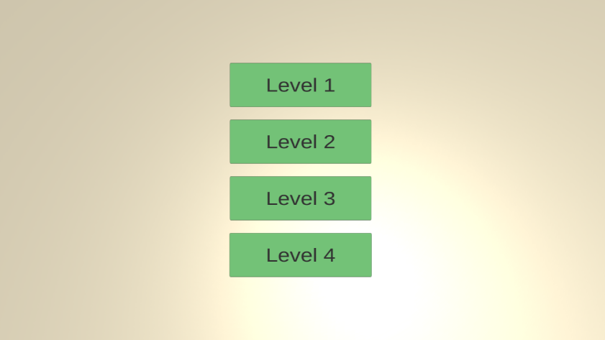

1. When the game starts try to touch the floating and rotating boxes with your player.

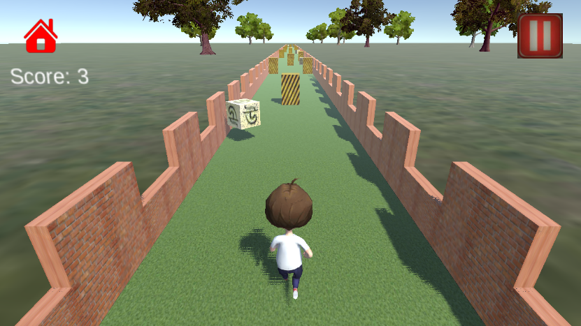

1. In order to move the player swap your finger over the phone screen.
2. Swap left to go to the left lane, swap right to move to right side.

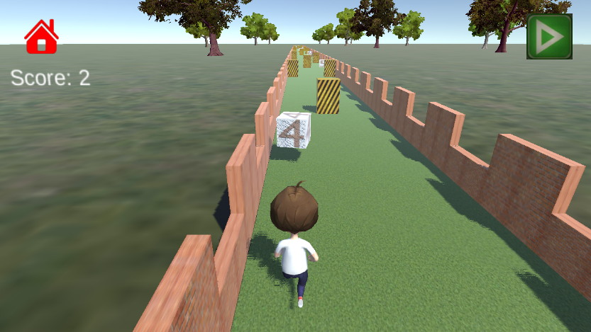

1. Try to avoid colliding with the obstacles. Game will be over if you collide.

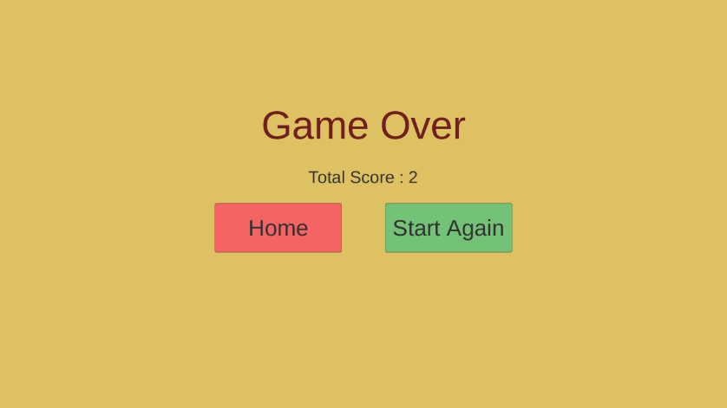

**Contact Us:**

**VistaSoft IT**

House # 20, Road # 02, Block # A, Section # 02(Rainkhola), Mirpur, Dhaka-1216, Bangladesh.

**Website:** [www.vistasoftit.org](http://www.vistasoftit.org)

**Email:** [vistasoftit@gmail.com](mailto:vistasoftit@gmail.com)